horizontal line

**Zombieland CLI Team**

Cali, Colombia

Weekly status report, 1 of 3.

# Automatic Translations, Skillshare.

**June 4, 2020**

##### **Team**

1. Carlos Andres Garcia (agzsoftsi)
2. Ivan Dario Lasso (ilasso)
3. Leonardo Calderon (leocjj)

# Progress

This is the first of three weekly progress reports to present the status of the project advance in order to achieve main goals, to meet the schedule and requirements from Holberton and the Client.

As we will show next, we achieved 86% (2 of 14) of mandatory requirements from the Client at this point, measured in Trello project (see links related). At this moment we are working on the rest of the mandatory tasks and on additional tasks that are nice-to-have. All mandatory tasks in Dev Complete column in Trello and completely deployed to a landing page fully operational.

On June 4 meeting, the Client representative accepts the actual progress as a project fully operational and suggests to start research on a possible deployment on production environment connecting the service developed in this project with the external services used in Client’s web page. We will start this advanced stage on the project, not accorded in original requirements, next week (June 8).

Mandatory tasks pending are related to additional tests and documentation and are in progress with an estimated finish date next week.

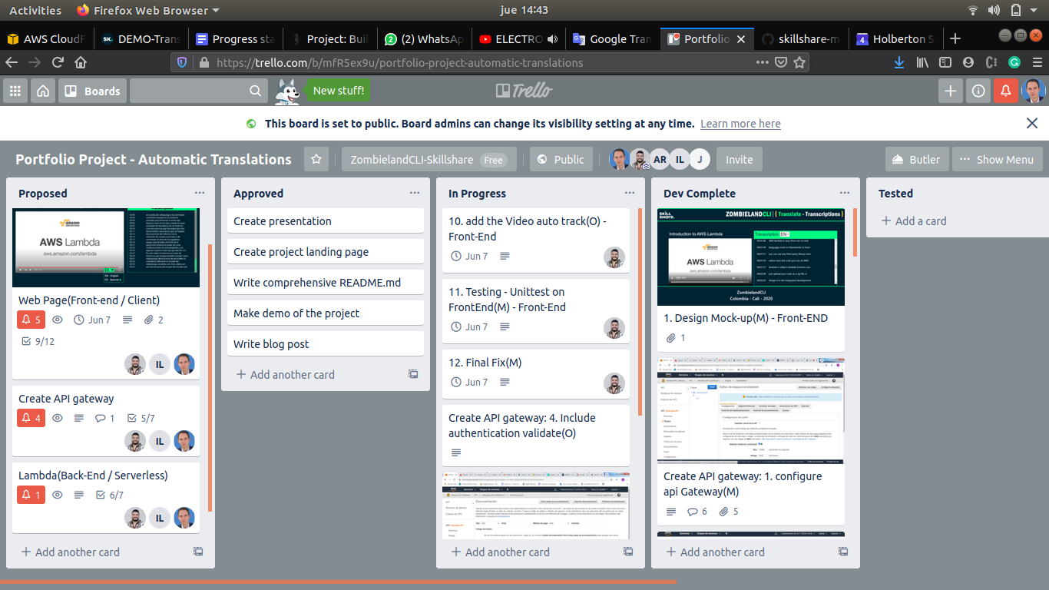  
Figure 1. Trello project plan (status on June 4)

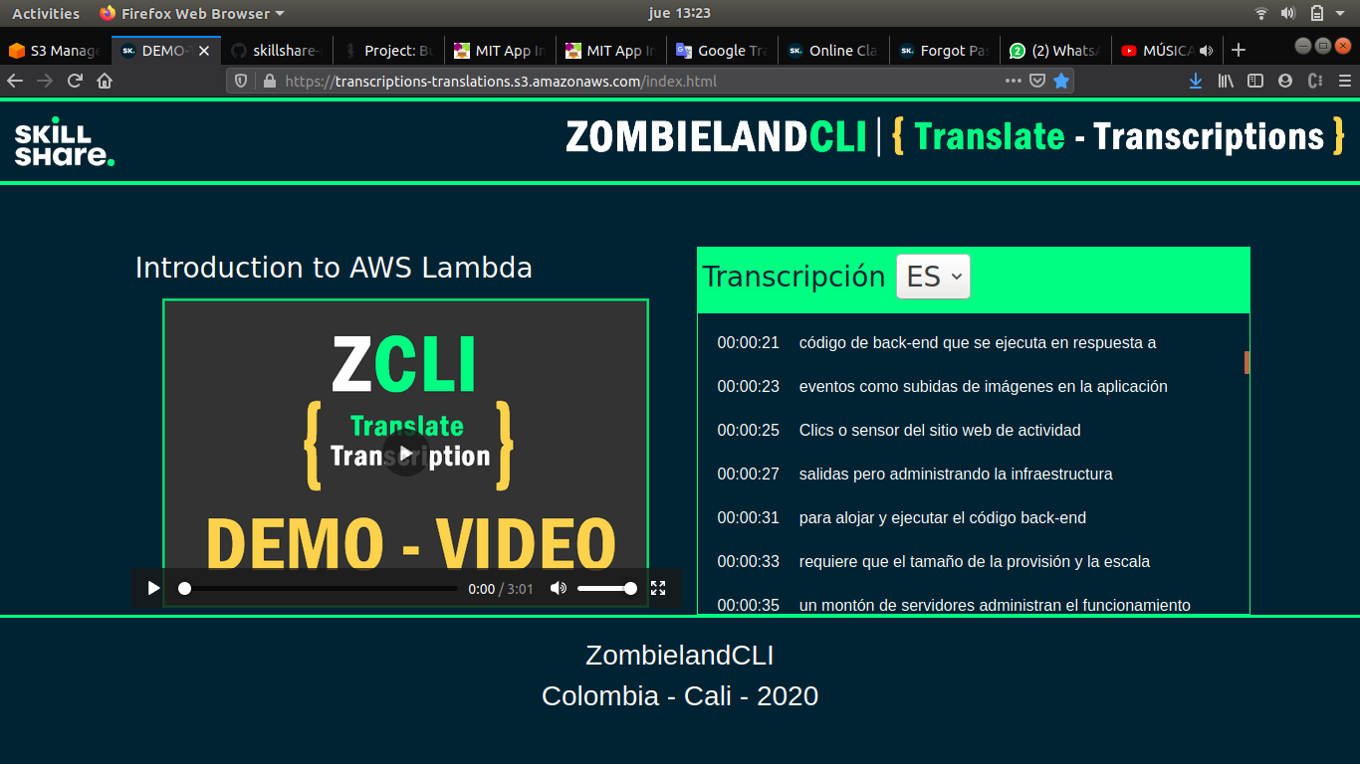  
Figure 2. Landing page for the service.

# 

# Challenges

The main challenges in the project are related to the use implementation of new technologies specifically AWS services required by the client to implement back-end functionality.

All data used for the project are also en AWS services as S3 objects from where we need to recover input transcriptions for the new translation service. The following are the main AWS services researched as part of the implementation:

* Lambda function
* S3 objects
* API Gateway
* Amazon Translate

In the middle of the project, we found a special limitation for using the Amazon Translate service, this is limited to 5000 words per request so we needed to implement some code to work with that and also to deal with the speed of the service to avoid long time of wait for the user when requesting a new language translation. No other situations were presented

However, the original plan did not change due to several tests performed in parallel by the members of the team and pair programming sessions that helped to overcome the issues.

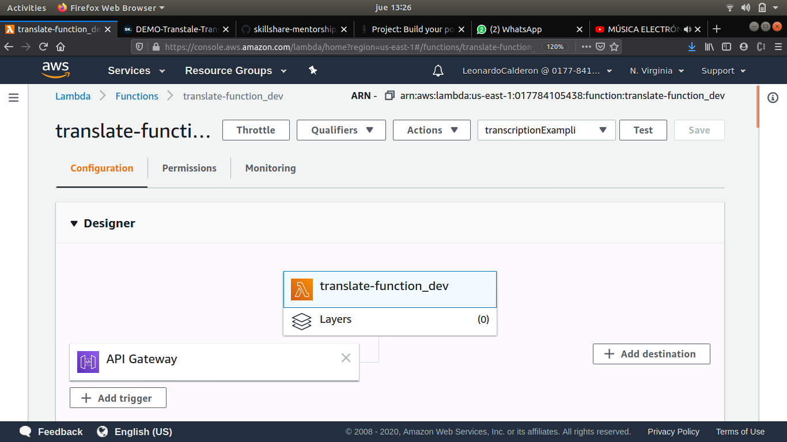  
Figure 3. Lambda function triggered by API Gateway request

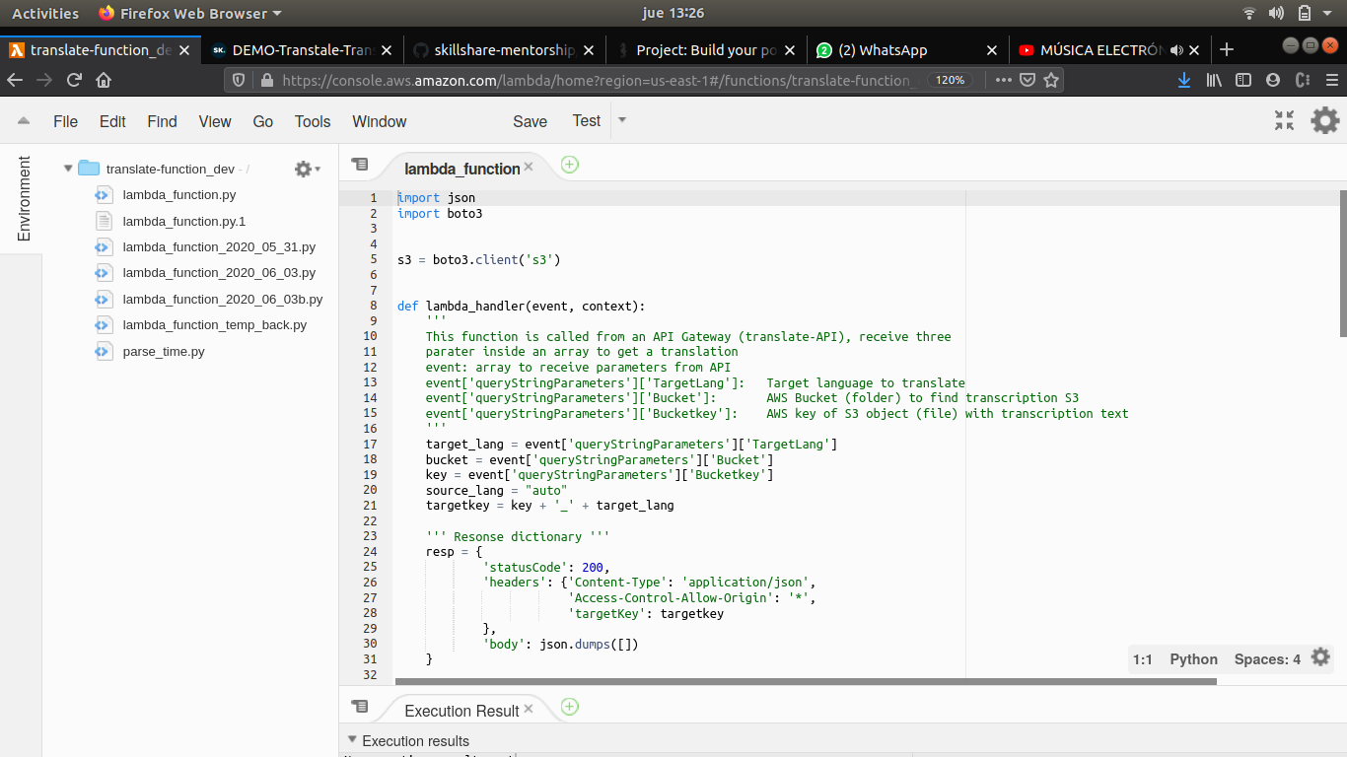  
Figure 4. Lambda function code in Python

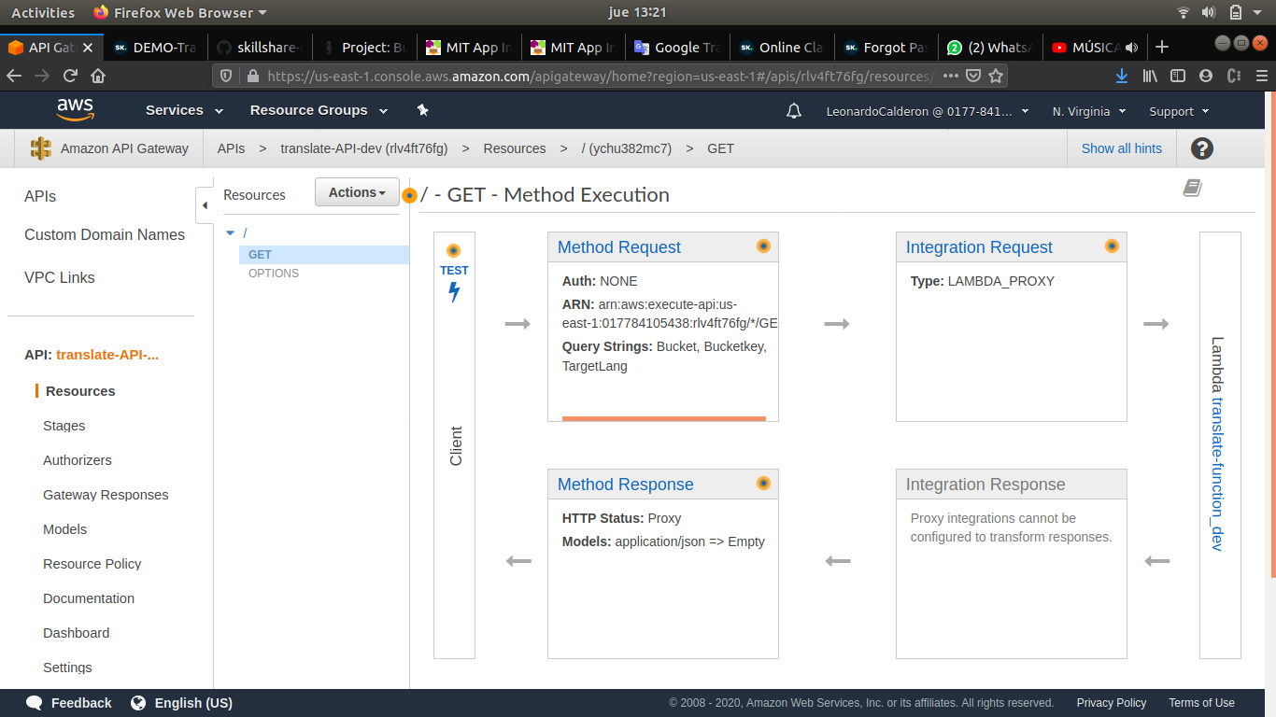  
Figure 5. API Gateway configuration of the GET method.  
  
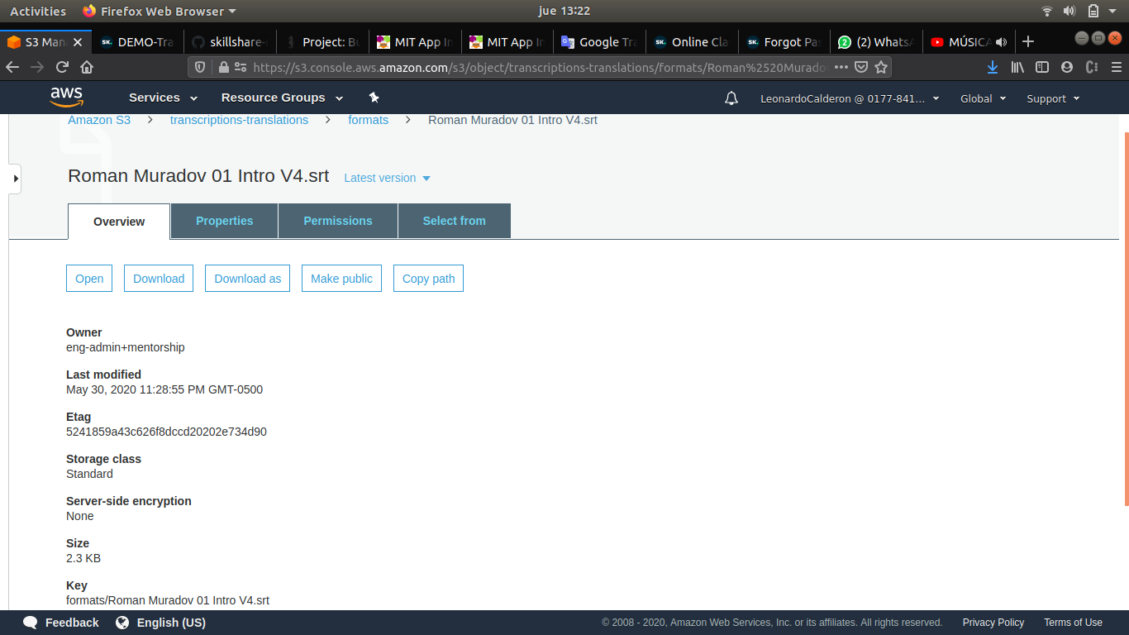  
Figure 6. S3 object in AWS

# Collaboration

We needed to deal with a special situation in this project. Due to global isolation, all the teamwork was performed remotely and we as members were forced to work virtually all the time. This was achieved using a videoconference service, individual accounts for Skillshare and AWS, development repository in GitHub, and a set of rules described next:

* Daily meeting with the Client representative was mandatory.
* Daily team meetings to share individual research and do pair programming to integrate codes and new features.
* Special rule to avoid migration to production code without the approval of all the team.

# Project Updates

According to the original requirements

Because we are one week in advance according to the schedule of the project, we decided to increase the scope and include some nice-to-have features and activities:

* Video auto-track front-end
* Authentication for API
* API documentation inside AWS
* Research deployment in real Skillshare production.

# Links related to the project

**Trello project:** <https://trello.com/b/mfR5ex9u/portfolio-project-automatic-translations>

**Landing page:** <https://transcriptions-translations.s3.amazonaws.com/index.html>

**Client’s page:** <https://www.skillshare.com/>

**Official repository:** <https://github.com/skillshare-mentorship/holberton-translate-transcriptions>